FlatCAD: Software For Rapid Prototyping With Flat Materials And A Laser Cutter

Gabe Johnson
Computational Design Lab
Carnegie Mellon University
Pittsburgh PA 15213 USA
johnsogg@cmu.edu
Shaun Moon
Computational Design Lab
Carnegie Mellon University
Pittsburgh PA 15213 USA
moon@cmu.edu

ABSTRACT
Rapid prototyping machines such as 3D printers, CNC mills, and laser cutters have given designers new tools for working. These machines help designers create artifacts that help expose problems with the current design so that an improved version can be made quickly. While commercial CAD software is powerful for creating complex things, general-purpose design environments do not adequately or specifically support rapid prototyping. In this paper we present FlatCAD, a design tool for crafting artifacts using inexpensive flat material produced with a laser cutter. We present our implementation plan followed by several use case stories that describe realistic scenarios in which FlatCAD could be beneficial.
Keywords
Rapid prototyping, CAD, design software, FlatCAD, FlatLang, sketching

INTRODUCTION
Prototyping is an important activity when designing all but the simplest of things. Software engineers make scaled-down versions of large systems; industrial designers craft foam and plastic into the shape of an experimental mobile phone; architects spend hours cutting and gluing bits of balsa wood together to make models of buildings.
There are many reasons that designers make prototypes, such as to communicate an idea, expose unforeseen problems, explore design variations, or demonstrate feasibility—just to name a few. The more easily designers can create prototypes, the sooner their goals can be accomplished, and the sooner the next iteration can begin.
Two critical elements of the prototyping process are the software and hardware tools. A designer uses software to translate ideas into digital artifacts. These digital artifacts can then be sent to an output device that creates physical artifacts. As the cost of rapid prototyping hardware continues to decline, fast fabrication should become increasingly accessible to small businesses, educational institutions and even individuals. However, the time and effort required to learn how to use most software tools remains prohibitive to the adoption of rapid prototyping. We would like to have a tool at our disposal for quickly creating physical prototypes using a laser cutter. Currently in order to do this we may use commercial design software such as AutoCAD, Adobe Illustrator, CorelDRAW, and so on. While these tools are powerful, they require beginners to spend a good deal of time and effort before having sufficient mastery to make anything useful. One web page describes a group of master’s students spending ten hours learning how to use commercial drafting software and a laser cutter to produce a simple box [1].

IMPLEMENTATION
This section describes the implementation plan for FlatCAD, a software system that allows designers who are not CAD experts to quickly produce physical output on a laser cutter. Example output includes boxes, building models, dollhouse furniture, mechanical systems involving struts and gears, or model skeletons. It is fully possible for these objects to be created with current software, but only after spending enough time to achieve a certain level of mastery. The effort involved in using current software for rapid prototyping with a laser cutter is high enough that few people have the patience to do it. Our aim for FlatCAD is to create a system that is powerful and easy to use in the specific context of rapid prototyping.

Material model and manipulation
At its core, FlatCAD concerns a material model and provides a small axiomatic set of operations to manipulate that model. FlatCAD is a design environment that works with flat material such as wood, plastic, paper, metal, or foam core. Each of these materials have their own properties that dictate how they may be used. For example, wood is sturdy but can not be readily bent or folded, whereas paper is not as sturdy but can be bent and folded with ease.
It is tempting to think of each piece of flat material as a simple 2D plane. However, even very thin material such as paper has a thickness that quickly becomes pertinent when performing certain operations such as folding sheets of paper many times. Therefore it is important that FlatCAD model material as truly 3D objects.
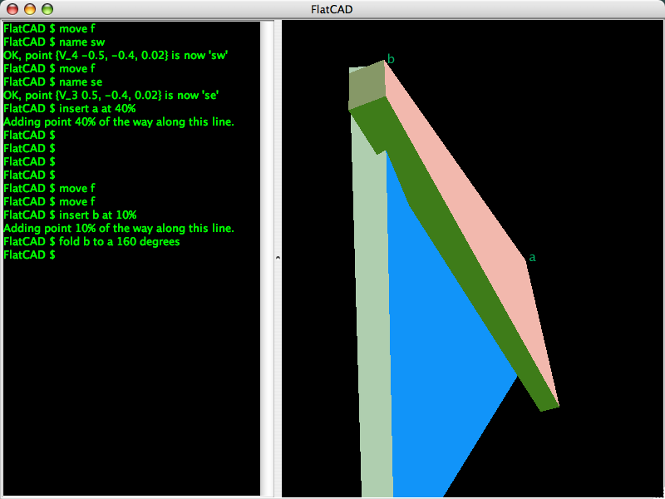
Figure 1: Current FlatCAD prototype. Left: Interactive FlatLang. Right: Associated 3D model of a 160-degree fold
FlatCAD must ultimately have the ability to handle a wide variety of materials on several different types of rapid prototyping machinery. However, we must scope our work in order to make progress on other fronts described below. For the first usable and useful implementation we restrict our materials and methods to sturdy media that can be cut on a laser cutter such as wood and acrylic.
The material model is manipulated using a small set of axiomatic operations. While the Flat part of the project name is not explicitly a mnemonic, it can be thought of as a reverse-engineered acronym describing four fundamental operations: fold, layer, attach, and trim. Some operations are potentially inappropriate for any given material. For example, wood and acrylic plastic does not fold (or if it does, only a little).

Three Modes of Interaction: WIMP, Code, Sketching
Some modes of interaction are more effective at expressing things than other modes. People are comfortable with traditional WIMP user interfaces, which have a powerful set of idioms like drag and drop. Writing code is good for tasks such as automatic generation of shapes or programmatic decision making. Sketch-based interaction is good for annotating models and working out problems without constraints imposed by formal notation or syntax. Each of these three modes of interaction have their strengths and weaknesses. FlatCAD will support each of these modes to give people more appropriate methods for designing.
First, the designer may use the mouse and keyboard in the traditional WIMP way. This is the dominant method and is used by all commercial design environments such as AutoCAD and SolidWorks.
Alternately, the user may interact with the model by programming in a domain-specific language we are developing called FlatLang. Figure 1 shows an interactive session of FlatLang where the user is typing commands directly, receiving visual and textual feedback. FlatLang programs may also be stored to disk and loaded dynamically.
FlatLang is a "little language" [2] that facilitates thinking about and manipulating geometries in FlatCAD. It gives users the ability to create algorithms that create and modify physical structures, similar to the functionality of FormWriter [3]. FlatLang provides a sort of “microworld” [4], a self-contained environment and language for working with flat material.
FlatLang serves as the conduit between the user and the underlying data model, as shown in Figure 2. All user actions are converted to some FlatLang code. This allows for a powerful end-user programming environment using FlatLang.
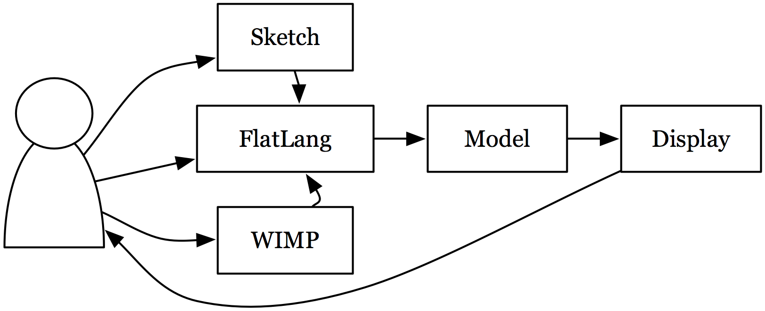
Figure 2: The relationship between the designer, the three modes of interaction, the model, and output.
Here is an example of how FlatLang can be used as a means of extending the capabilities of FlatCAD. One of the axiomatic operations is attach. There are many ways to join two pieces of material: Gluing their edges together, creating notches or finger joints, just to name a few. We can not encode every possible method of joining two pieces of material together. But if we provide a means for working with material in a language that is easy to work with, we will give users the ability to define their own custom attachment routines or use FlatLang code written by other users.
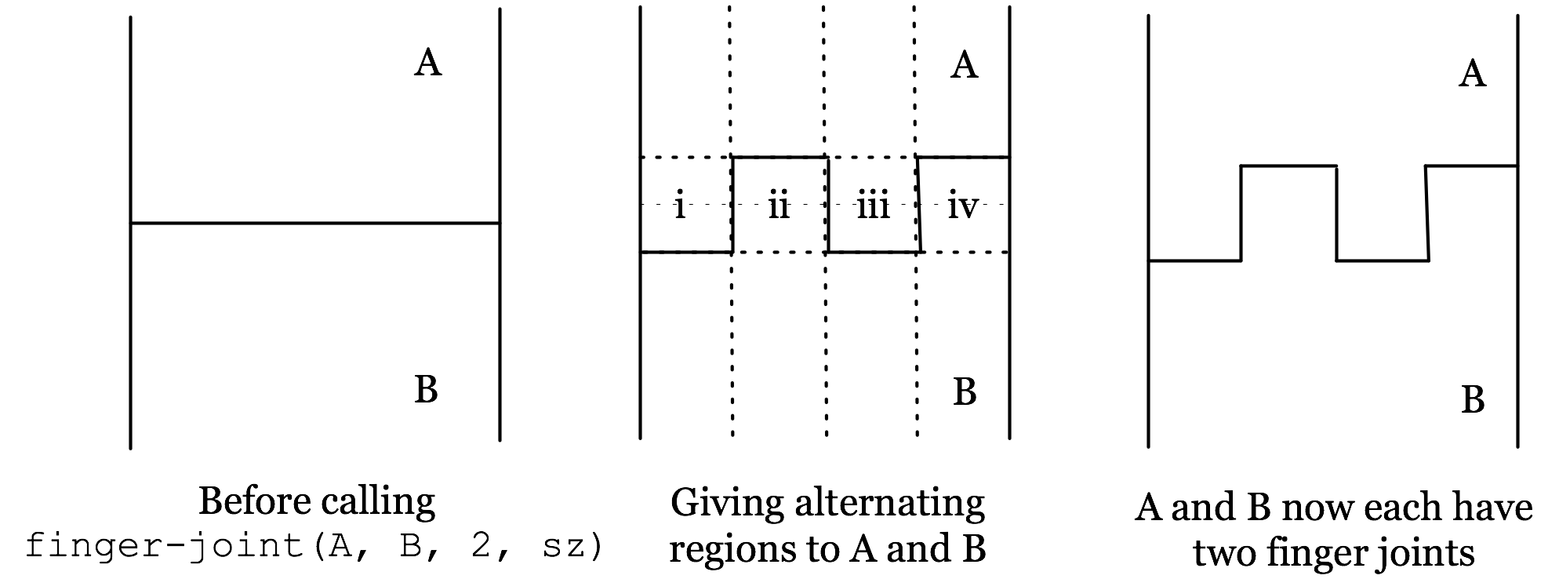
Figure 3: Visualization of the finger-joint routine for creating a finger joint between two sheets of material.
Consider the task of creating a finger joint. Figure 3 displays the progress of a routine that creates a simple finger joint between two adjacent pieces of material, A and B. Figure 4 lists one possible implementation of this process.
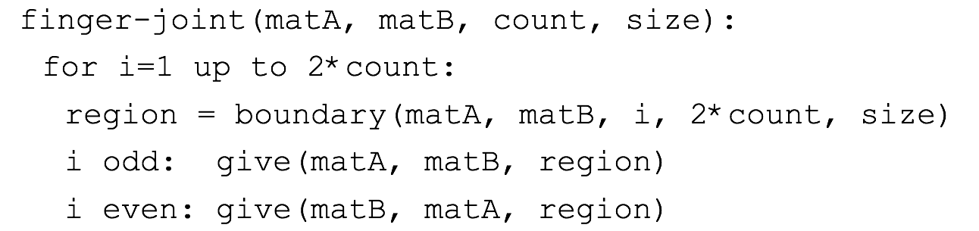
Figure 4: FlatLang code for producing finger joints
The finger-joint function creates an interlocking structure by exchanging regions between two pieces of material. This code depends on a boundary function that creates a 2D region out of material on either side of the edge shared by two pieces. The joining process also relies on a give function that adds a region to one piece while removing it from another.
We intend to add support for sketching as a third mode of interaction. This interaction differs from mouse input in that sketches done with a stylus may be interpreted as writing or modeling operations, or they may be uninterpreted as simple annotations.
Designers frequently make rough sketches of objects in order to think through issues such as how various parts will relate to one another, or to simply visualize their intentions in a process of “backtalk” [5]. Sketches serve as a cognitive tool for working through ideas that are not fully formed, allowing designers to reinterpret their ongoing work, thus providing people with a powerful means for creating new artifacts [6].

Parameters and Constraints
FlatCAD will support parametric design. The finger joint routine discussed above is an example parameterization: the designer indicates the need to have a joint with two fingers on each piece, and the software performs the necessary actions to make that happen. There are many measurements that can be parameterized including length, angle, radius, or higher level notions such as the number of fingers in a finger joint.
Constraint-based design [7] is another powerful strategy for creating artifacts that FlatCAD will support. For example, a designer may indicate that adjacent edges of two parts must have the same length. Adjusting the length of one would therefore cause the other to change accordingly.

Design for Assembly
Our personal experience and observations of student work at CMU has shown that the manufacture and assembly phase of prototyping is particularly problematic. Designers often make complex models with many different parts that must be laser-cut and assembled by hand. Using current commercial CAD software, it is common to spend a good deal of time arranging parts on the ‘print preview’ interface in order to economize material or ensure that the parts appear within the physical confines of the laser cutter. FlatCAD will generate intelligent output for manufacture that makes efficient use of the material by minimizing waste like that shown in Figure 7.
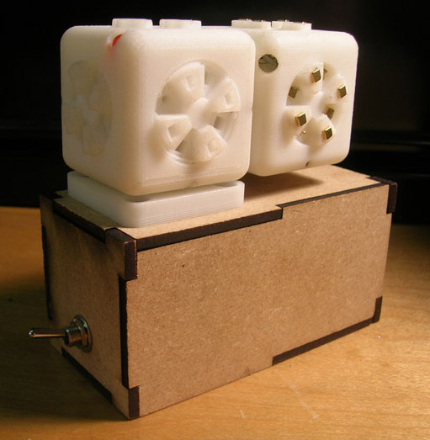  Figure 5: A simple box built from laser-cut pieces of wood. Note the regularity of the jointing pattern. | 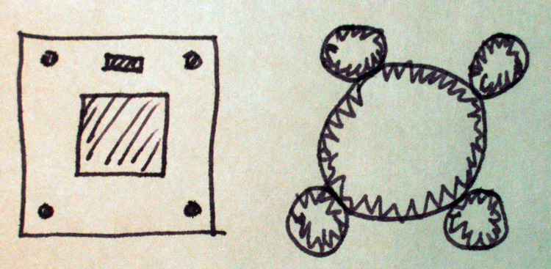  Figure 6: A designer’s sketch of a mounting bracket (left) and a system of gears (right). | 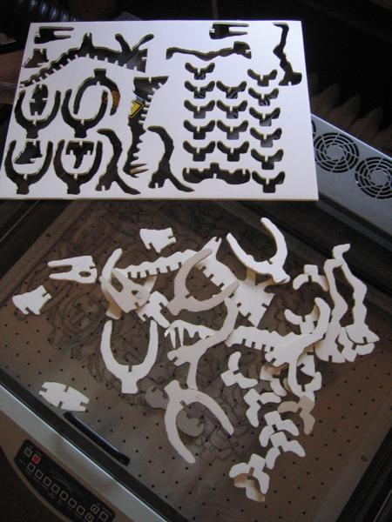  Figure 7: Foam core dinosaur bones along with waste material sitting on a laser cutter.
Complicated models with dozens or hundreds of parts are somewhat like jigsaw puzzles to assemble. FlatCAD can optionally support this activity by using the laser cutter’s engraving capabilities and etching labels onto parts that fit together. These labels can expedite the manual assembly process.

USE CASE STORIES
Here we provide three use case stories to guide development and serve as test cases to see if FlatCAD works as advertised. These are actual examples from CMU student projects, all of which predates the FlatCAD project.
Use Story 1—Construction Kits: FlatCAD’s predecessor systems include the Designosaur and the Furniture Factory [8]. These two projects supported novice designers in creating construction kits such as dinosaur skeletons and dollhouse furniture (Figure 7). Both of these systems featured sketch-based interfaces for letting users indicate shapes to be cut out. FlatCAD will be able to support people in making construction kits of this sort.
Use Story 2—“BoxCAD”: Designers often incorporate everyday objects such as boxes and gears into their designs. These items are good candidates for parametric modeling because their shapes can be described numerically and generated with an algorithm.
In this scenario the designer needs a simple box to house a power supply. FlatCAD has a built-in “box utility” that gives the designer a rectangular box using a default jointing structure with the desired dimensions. This may be as simple as typing box(2,2,5) into the FlatLang interpreter. The designer may then modify the resulting object to fit their particular needs. An example of such a box is shown in Figure 5.
FlatCAD can also be used to create mechanical systems from flat material. Several students in past projects have made custom gears cut from foam core or acrylic. This activity is similar to that supported by Blauvelt’s MachineShop system for designing mechanical parts such as gears and cams for production on a laser cutter [9].
Use Story 3—Mechanical Design: This scenario demonstrates the interaction between sketches, constraints, and the use of parametric objects. The designer needs to create a square mounting bracket with four screw holes in each corner, a large square hole in the center, and a small rectangular hole between two of the screw holes. A tiny machine consisting of gears will be mounted onto this bracket. This mechanical system is composed of a large gear in the middle that is surrounded by four smaller gears, each of which is centered about a screw hole. Refer to this scenario’s sketch in Figure 6.
This rough sketch uses idioms to represent actions and objects. For example, the hatched region in the center of the mounting bracket indicates the area should be cut out. The jagged teeth on the circles could be interpreted as gears. There are many strategies for recognizing sketches, such as template matching [10], stroke feature analysis [11], and forming belief networks concerning the context of sketches [12].
If a sketch can not be recognized by the simple drawing, the designer may clarify or disambiguate their intentions by other means, such as by writing the word “gears”.
In this drawing the four small gears seem to be tangent to the larger one, implying a constraint that if the user changes the size of the larger gear the smaller circles would either change size or move to satisfy the constraint. Further, the distance between the screw holes can be used constrain the center of the smaller gears.
The gears themselves are instances of parametric objects. Gear instances have reasonable defaults concerning parametric features such as the number, width, and length of teeth.

EXPECTED BENEFIT OF PARTICIPATION
It is important to discuss ideas with new people in order to gain fresh perspectives. Conversing with other smart and creative people will help us make better informed decisions on our own research. We believe that one of the best ways to debug one’s own research is to help others debug their work. Systems-oriented research has a tendency to become intensely personal, making it difficult to remain objective. By interacting with new people and debugging each other’s research, people gain skills in becoming objective of their own research.

ACKNOWLEDGMENTS
FlatCAD is a project in the Computation Design Lab at Carnegie Mellon University. It is funded by NSF Grant ITR-0326054. We would also like to thank Mark Gross, Ellen Do, and Eric Schweikardt for guidance and valuable feedback.

REFERENCES
1. Weblog. http://tinyurl.com/yxvewm
2. Bentley, J.L., Little Languages -- Programming Pearls. Communications of the ACM, 1986. 29(August): p. 711-721.
3. Gross, M.D. FormWriter: A Little Programming Language for Generating Three-Dimensional Form Algorithmically. in CAAD Futures. 2001.
4. Papert, S., Mindstorms. 1980, New York: Basic Books.
5. Goldschmidt, G., The Backtalk of Self-Generated Sketches, in Spatial and Visual Reasoning in Design. 1999, Key Center of Design Computing: Syndey, Australia.
6. Goel, V., Sketches of Thought. 1995, Cambridge, MA: MIT Press/A Bradford Book.
7. Badros, G.J., A. Borning, and P.J. Stuckey, The Cassowary Linear Arithmetic Constraint Solving Algorithm. ACM Transactions on Computer Human Interaction. 8(4): p. 267-306.
8. Oh, Y., et al. The Designosaur and the Furniture Factory: Simple Software for Fast Fabrication. in Second International Conference on Design Computing and Cognition. 2006. Eindhoven, The Netherlands.
9. Blauvelt, G. and M. Eisenberg. Printing Reconsidered: Exploring New Directions for Output Devices in Educational Technology. in International Conference of the Learning Sciences. 2002. Seattle, Washington.
10. Kara, L.B. and T.F. Stahovich, An image-based, trainable symbol recognizer for hand-drawn sketches. Computers & Graphics, 2005. 29(4): p. 501-517.
11. Long, A.C., et al., Visual similarity of pen gestures, in Proceedings of the SIGCHI conference on Human factors in computing systems. 2000, ACM Press: The Hague, The Netherlands.
12. Alvarado, C. and R. Davis. Dynamically Constructed Bayes Nets for Multi-Domain Sketch Understanding. in International Joint Conference on Artificial Intelligence. 2005.

